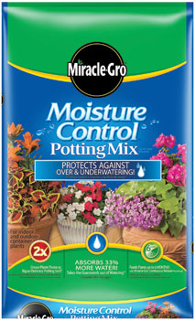
Moisture Control Potting Mix
- 2Cubic Foot
- Feeds for up to 6 Months
- Holds 33% more water than soil

$12.99
7301609

